Bias and Variance in Machine Learning
Last Updated : 12 Jul, 2025
Bias and Variance in Machine Learning - GeeksforGeeks
https://www.geeksforgeeks.org/machine-learning/bias-vs-variance-in-machine-learning/
There are various ways to evaluate a machine-learning model. We can use MSE (Mean Squared Error) for Regression; Precision, Recall, and ROC (Receiver operating characteristics) for a Classification Problem along with Absolute Error. In a similar way, Bias and Variance help us in parameter tuning and deciding better-fitted models among several built.
Bias is one type of error that occurs due to wrong assumptions about data such as assuming data is linear when in reality, data follows a complex function. On the other hand, variance gets introduced with high sensitivity to variations in training data. This also is one type of error since we want to make our model robust against noise. There are two types of error in machine learning. Reducible error and Irreducible error. Bias and Variance come under reducible error.
What is Bias?
Bias is simply defined as the inability of the model because of that there is some difference or error occurring between the model's predicted value and the actual value. These differences between actual or expected values and the predicted values are known as error or bias error or error due to bias. Bias is a systematic error that occurs due to wrong assumptions in the machine learning process.
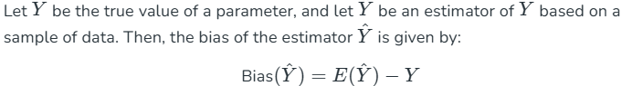
where E(Y^) is the expected value of the estimator Y^. It is the measurement of the model that how well it fits the data.
- Low Bias: Low bias value means fewer assumptions are taken to build the target function. In this case, the model will closely match the training dataset.
- High Bias: High bias value means more assumptions are taken to build the target function. In this case, the model will not match the training dataset closely.
Ways to reduce high bias in Machine Learning:
- Use a more complex model: One of the main reasons for high bias is the very simplified model. it will not be able to capture the complexity of the data. In such cases, we can make our mode more complex by increasing the number of hidden layers in the case of a deep neural network. Or we can use a more complex model like Polynomial regression for non-linear datasets, CNN for image processing, and RNN for sequence learning.
- Increase the number of features: By adding more features to train the dataset will increase the complexity of the model. And improve its ability to capture the underlying patterns in the data.
- Reduce Regularization of the model: Regularization techniques such as L1 or L2 regularization can help to prevent overfitting and improve the generalization ability of the model. if the model has a high bias, reducing the strength of regularization or removing it altogether can help to improve its performance.
- Increase the size of the training data: Increasing the size of the training data can help to reduce bias by providing the model with more examples to learn from the dataset.

The high-bias model will not be able to capture the dataset trend. It is considered as the underfitting model which has a high error rate. It is due to a very simplified algorithm.
For example, a linear regression model may have a high bias if the data has a non-linear relationship.
What is Variance?
Variance is the measure of spread in data from its mean position. In machine learning variance is the amount by which the performance of a predictive model changes when it is trained on different subsets of the training data. More specifically, variance is the variability of the model that how much it is sensitive to another subset of the training dataset. i.e. how much it can adjust on the new subset of the training dataset. 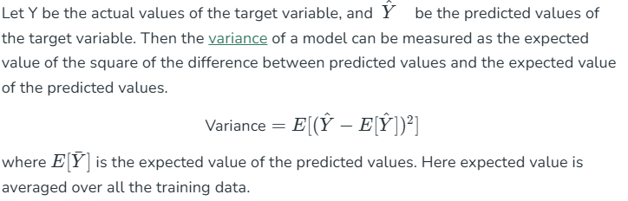
Variance errors are either low or high-variance errors.
- Low variance: Low variance means that the model is less sensitive to changes in the training data and can produce consistent estimates of the target function with different subsets of data from the same distribution. However, low variance can also indicate underfitting if the model is too simple and fails to capture the underlying patterns in the data. This is when the model performs poorly on both the training data and testing data.
- High variance: High variance means that the model is very sensitive to changes in the training data and can result in significant changes in the estimate of the target function when trained on different subsets of data from the same distribution. This is the case of overfitting when the model performs well on the training data but poorly on new, unseen test data. It fits the training data too closely that it fails on the new training dataset.
Ways to Reduce the reduce Variance in Machine Learning:
- Cross-validation: By splitting the data into training and testing sets multiple times, cross-validation can help identify if a model is overfitting or underfitting and can be used to tune hyperparameters to reduce variance.
- Feature selection: By choosing the only relevant feature will decrease the model's complexity. and it can reduce the variance error.
- Regularization: We can use L1 or L2 regularization to reduce variance in machine learning models
- Ensemble methods: It will combine multiple models to improve generalization performance. Bagging, boosting, and stacking are common ensemble methods that can help reduce variance and improve generalization performance.
- Simplifying the model: Reducing the complexity of the model, such as decreasing the number of parameters or layers in a neural network, can also help reduce variance and improve generalization performance.
- Early stopping: Early stopping is a technique used to prevent overfitting by stopping the training of the deep learning model when the performance on the validation set stops improving.

Mathematical Derivation for Total Error
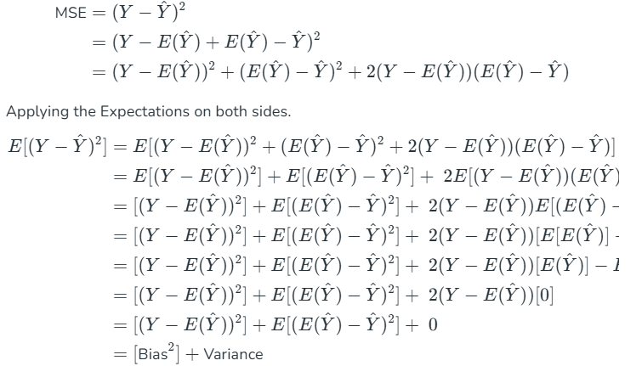
Different Combinations of Bias-Variance
There can be four combinations between bias and variance.
 |  | Variance
 |  | Low | High
Bias | Low | 1. Ideal Scenario for ML Model  2.it Means Model is able to capture the Underlying Patterns in the data (i.e Bias) and is not too sensitive to changes in the training dataset(i.e Variance)  3. It is able to generalize well to new unseen data  4. But Practically, achieving this is difficult | Overfitting
 | High | Underfitting | 1. It means model is not able to capture the Underlying Patterns  2. Model is too sensitive to the changes in the training Dataset  3.Hence, Model will predict inconsistent and inaccurate predictions on average..

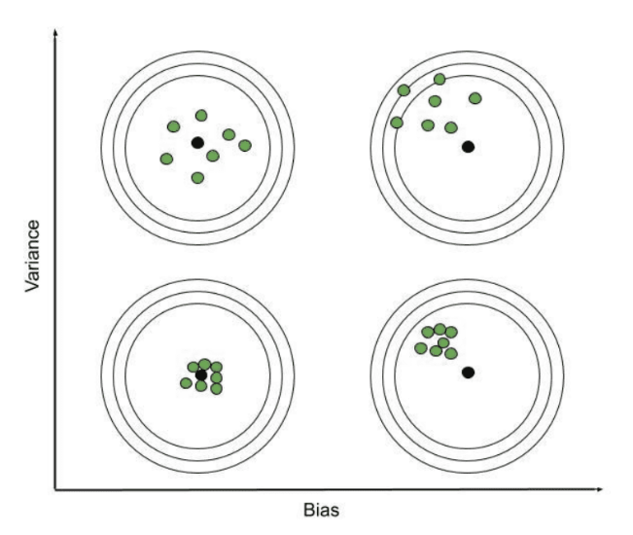

- High Bias, Low Variance: A model with high bias and low variance is said to be underfitting.
- High Variance, Low Bias: A model with high variance and low bias is said to be overfitting.
- High-Bias, High-Variance: A model has both high bias and high variance, which means that the model is not able to capture the underlying patterns in the data (high bias) and is also too sensitive to changes in the training data (high variance). As a result, the model will produce inconsistent and inaccurate predictions on average.
- Low Bias, Low Variance: A model that has low bias and low variance means that the model is able to capture the underlying patterns in the data (low bias) and is not too sensitive to changes in the training data (low variance). This is the ideal scenario for a machine learning model, as it is able to generalize well to new, unseen data and produce consistent and accurate predictions. But in practice, it's not possible.
Now we know that the ideal case will be Low Bias and Low variance, but in practice, it is not possible. So, we trade off between Bias and variance to achieve a balanced bias and variance.
A model with balanced bias and variance is said to have optimal generalization performance. This means that the model is able to capture the underlying patterns in the data without overfitting or underfitting. The model is likely to be just complex enough to capture the complexity of the data, but not too complex to overfit the training data. This can happen when the model has been carefully tuned to achieve a good balance between bias and variance, by adjusting the hyperparameters and selecting an appropriate model architecture.
Machine Learning Algorithm | Bias | Variance
Linear Regression | High Bias | Less Variance
Decision Tree | Low Bias | High Variance
Random Forest | Low Bias | High Variance
Bagging | Low Bias | High Variance

Bias Variance Tradeoff
If the algorithm is too simple (hypothesis with linear equation) then it may be on high bias and low variance condition and thus is error-prone. If algorithms fit too complex (hypothesis with high degree equation) then it may be on high variance and low bias. In the latter condition, the new entries will not perform well. Well, there is something between both of these conditions, known as a Trade-off or Bias Variance Trade-off. This tradeoff in complexity is why there is a tradeoff between bias and variance. An algorithm can’t be more complex and less complex at the same time. For the graph, the perfect tradeoff will be like this.
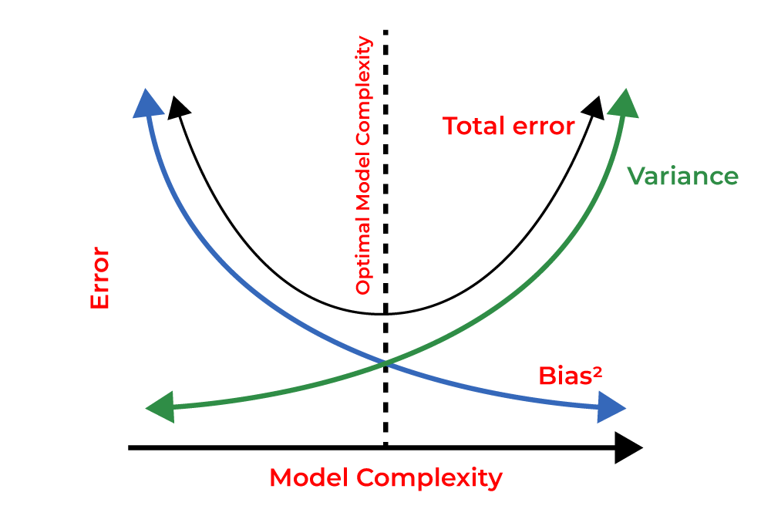
Bias Variance Decomposition for Classification and Regression
As per the formula, we have derived total error as the sum of Bias squares and variance. We try to make sure that the bias and the variance are comparable and one does not exceed the other by too much difference.

# Import the necessary libraries
from sklearn.datasets import load_iris
from sklearn.model_selection import train_test_split
from sklearn.tree import DecisionTreeClassifier
from sklearn.ensemble import BaggingClassifier
from mlxtend.evaluate import bias_variance_decomp
import warnings
warnings.filterwarnings('ignore')

# Load the dataset
X, y = load_iris(return_X_y=True)

# Split train and test dataset
X_train, X_test,\
y_train, y_test = train_test_split(X, y,
test_size=0.25,
random_state=23,
shuffle=True,
stratify=y)

# Build the classification model
tree = DecisionTreeClassifier(random_state=123)
clf = BaggingClassifier(base_estimator=tree,
n_estimators=50,
random_state=23)

# Bias variance decompositions
avg_expected_loss, avg_bias, \
avg_var = bias_variance_decomp(clf,
X_train, y_train,
X_test, y_test,
loss='0-1_loss',
random_seed=23)
# Print the value
print('Average expected loss: %.2f' % avg_expected_loss)
print('Average bias: %.2f' % avg_bias)
print('Average variance: %.2f' % avg_var)

Output:
Average expected loss: 0.06
Average bias: 0.05
Average variance: 0.02

Now let's perform the same on the regression task. And check the values of the bias and variance.

# Load the necessary libraries
from sklearn.datasets import fetch_california_housing
from sklearn.model_selection import train_test_split
from sklearn.metrics import mean_squared_error
import tensorflow as tf
from mlxtend.evaluate import bias_variance_decomp
import warnings
warnings.filterwarnings('ignore')

# Laod the dataset
X, y = fetch_california_housing(return_X_y=True)

# Split train and test dataset
X_train, X_test,\
y_train, y_test = train_test_split(X, y,
test_size=0.25,
random_state=23,
shuffle=True)

# Build the regression model
model = tf.keras.Sequential([
tf.keras.layers.Dense(64, activation=tf.nn.relu),
tf.keras.layers.Dense(1)
])

# Set optimizer and loss
optimizer = tf.keras.optimizers.Adam()
model.compile(loss='mean_squared_error',
optimizer=optimizer)

# Train the model
model.fit(X_train, y_train, epochs=25, verbose=0)
# Evaluations
accuracy = model.evaluate(X_test, y_test)
print('Average: %.2f' % accuracy)

# Bias variance decompositions
avg_expected_loss, avg_bias,\
avg_var = bias_variance_decomp(model,
X_train, y_train,
X_test, y_test,
loss='mse',
random_seed=23,
epochs=5,
verbose=0)

# Print the result
print('Average expected loss: %.2f' % avg_expected_loss)
print('Average bias: %.2f' % avg_bias)
print('Average variance: %.2f' % avg_var)

Output:
162/162 [==============================] - 0s 802us/step - loss: 0.9195
Average: 0.92
Average expected loss: 2.30
Average bias: 0.72
Average variance: 1.58

